

**Placement Empowerment Program**

***Cloud Computing and DevOps Centre***

***Use Git Hooks for Automation****: Create a Git hook that automatically runs tests before committing code to your repository.*

***Name: VIJAYA NANDANA M Department: CSE***

**Introduction**

This Proof of Concept (PoC) demonstrates the use of Git hooks to automate the process of running tests before committing code to a repository. Specifically, it uses the pre-commit hook, which triggers test execution via pytest for a Python project. The goal is to ensure that only code that passes the specified tests is committed to the version control system, thus maintaining code quality and preventing faulty code from being pushed to the repository.

**Objectives**

* Automate testing by setting up a pre-commit hook to trigger tests before commits.
* Integrate pytest, a powerful testing framework, to run automated tests on the Python code.
* Ensure only error-free, validated code is committed, preventing bugs and improving code stability.
* Learn how to utilize Git hooks for automating routine tasks in the development lifecycle.
* Implement a seamless, automatic testing process that helps developers focus on writing code rather than performing manual checks.

**Step by Step Overview**

**1. Create a sample python file**

Create a folder in Desktop named my-python-project and Open Notepad Write the Python function to add two numbers and Save the file as ***my_function.py*** in your folder.

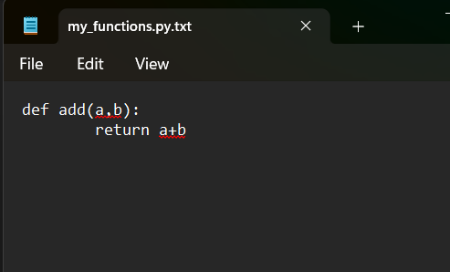

**2. Create test function**

Open Notepad again to create the test file and Write the test case code to test the add function and Save the test file as test_my_function.py in the same folder where my_function.py is saved.

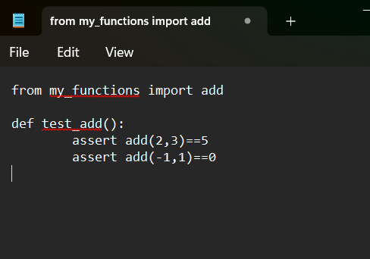

**3. Run the python file**

Open GitBash and Navigate to the folder where the files are saved.



Install pytest using pip by running the following command: ***pip install pytest.***

Now that we have the function and test cases, let’s run pytest to check if everything works.

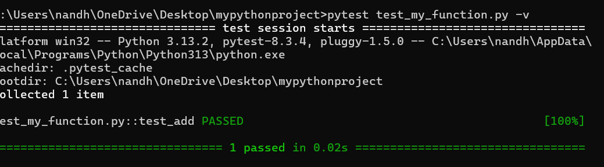

**4. Run Git**

- Run the following command to initialize Git in your project folder : ***git init***



Copy the sample file to a new file called pre-commit (no .sample extension):

***cp .git/hooks/pre-commit.sample .git/hooks/pre-commit***



**5. Open the hooks folder**

Open Notepad and type the following code and save as pre-commit in Inside the .git folder, open the hooks folder:

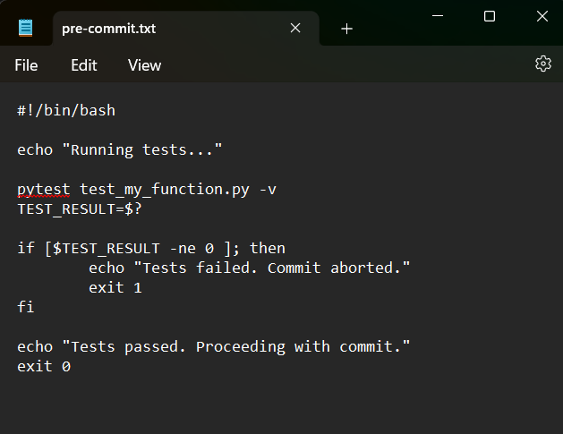

**6**. Once the file is saved, you need to make it executable. You can do this by running the following command in Git Bash:

***chmod +x .git/hooks/pre-commit***



**7. Test**

You can test it by staging and committing some changes:

• Stage your changes: ***git add .***

• Commit the changes: ***git commit -m "Testing pre-commit hook"***

**Outcome:**

* Implement a pre-commit hook that automatically triggers test execution before every commit, ensuring that only valid code is committed.
* Integrate pytest with Git hooks to run automated unit tests, improving the overall code quality and preventing the introduction of bugs into the repository.
* Learn to automate common tasks using Git hooks, enhancing your understanding of version control automation in the development process.